Proposal for the International Meeting SERVAS Romania
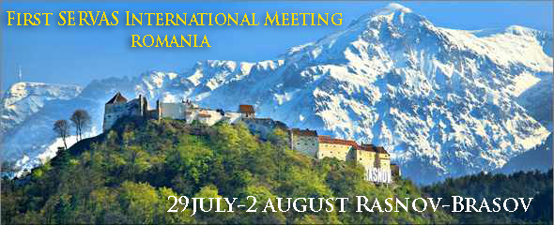
An island of latin blood in a sea of slave peoples.
Little Paris. Bucharest.
Dracula? Transylvania.
22 million inhabitants.
24 Servas members. Well, things have undergone some changes lately, and we are happy to announce that Servas Romania has added 12 more hosts in the past year. We would like to celebrate with you and share with you one of the most beautiful areas in the country-right in its middle.
We’re a very dynamic organization, we’re very eager to hear your stories and we invite you to share them with us.
More than half our members are young families who wish to experience the International Servas spirit. We have lots of friends who ‘d like to join Servas and then share their experiences . We would like the Servas spirit and values to be embraced by as many people as possible.
Romania is a beautiful country with lots of traditions, a rich and varied culture and we would like you to have a “taste” of all these things and then we are convinced you will return. Accidentally it is also an area very rich in myths, so any myth buster can try his hand here.
We hereby invite you to our Servas meeting-party.
The number of available places is “relatively” limited, so we kindly ask you to send your application request by May 1st, 2015, to be able to handle all logistical issues.
We have two different options for lodging, camping in nature, in a splendid landscape, or in a double or triple pension room.
The schedule has two main goals: on one hand, we will have a “Servas Values” section, where we invite everyone to make presentations and on the other hand we will have the “Romania in the world “ section, where we, the people at Servas Romania will try to delight you with our cultural and culinary specialties which made so many travellers return to these places.
Date: Wednesday, 29th of July – Sunday, 2nd of August 2015
WHERE: Rasnov (15 km of Brasov)

Details about cost you can find on registration form.

Depending on the number of peoples , there will be an additional cost for transport and special programs like visit and meal to sheepfold, which we will communicate when completing entries.
Bring items "to change", and comfortable shoes for hiking. We are in a mountainous area.

Proposed Program:
- 29th of July: arrival and welcoming of guests in Rasnov (Brasov county) the gathering will take place at Bogdan and Nicole Ionescu’s camping site. A welcoming drink and food sharing as well as stories are included for the evening.
Ideas – beans slowly cooked in a marmite (with or without pork knuckle);
- 30th of July: visiting Rasnov (fortress) – Bran (castle) – visiting a traditional sheepfold (Bordeianu family).
Cheese and pastrami tasting.
Rasnov – Bran = 13 km.
- 31st of July: visiting Fagaras (Stories and canvas museum + citadel) – Saxon fortified churches (Cincu, Cincsor, Merghindeal, Dealu Frumos and/or Iacobeni).
Camping in Dealu Frumos in the court yard of Neghina family.
Sinca Veche – Fagaras = 25 km; Fagaras – Dealu Frumos = 70 km
- 1st of August: visiting Sighisoara (citadel + church and cemetery + wood carving) – going back to Rasnov via Brasov (visiting Black Church/The Grand Square) – Rasnov.
DF - Sighisoara = 60 km; Sighisoara – Brasov = 118 km; Brasov – Rasnov = 10 km;
- 2nd of August: optional visiting Cantacuzino palace on Prahova Valley or hiking to Babele.

